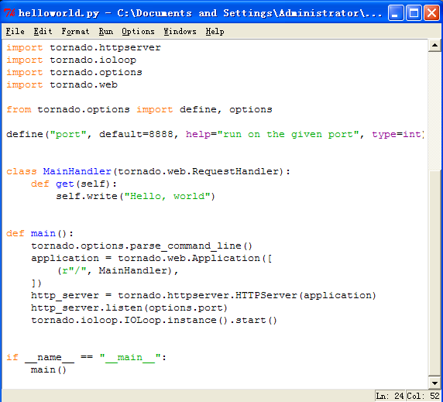

基于版本1.0版本

**tornado.options** — Command-line parsing

tornado/options.py里面

有个全局的options = _Options.instance() #用来存储_Option对象

类

class **_Options**(dict)

class **_Option**(object)

def **define**(name, default=None, type=str, help=None, metavar=None,

multiple=False):

options[name] = _Option(name, ...) #存储定义对象

def **parse_command_line**(args=None):

for arg in arg[1:]:

name, equals, value = arg.partition("=")

option = options[name]

option.parse(value) 转换option对象的值

tornado.web

绑定路径和回调函数

class **Application**(object):

def **__init__**(*self*, handlers=None, default_host=*""*, transforms=None,

wsgi=False, **settings):

self.handlers = []

for spec in handlers:

pattern , handler ,kwargs = spec

spec = URLSpec(pattern, handler, kwargs)

handlers.append(spec)

self.handlers.append((re.compile(".*$"), handlers))

def **__call__**(*self*, request):

*"""Called by HTTPServer to execute the request."""*

handlers = *self*._get_host_handlers(request)

for spec in handlers:

match = spec.regex.match(request.path)

if match:

handler = spec.handler_class(*self*, request, **spec.kwargs)

break

handler._execute(transforms, *args, **kwargs)

return handler

class **RequestHandler**(object):

def **__init__**(*self*, application, request, transforms=None):

*self*._finished = False

*self*._auto_finish = True

def **_execute**(*self*, transforms, *args, **kwargs):

*"""Executes this request with the given output transforms."""*

if not *self*._finished:

getattr(*self*, *self*.request.method.lower())(*args, **kwargs)

if *self*._auto_finish and not *self*._finished:

*self*.finish()

def **finish**(*self*, chunk=None):

*"""Finishes this response, ending the HTTP request."""*

assert not *self*._finished

。。。。

*self*._finished = True

* [**tornado.iostream** — Convenient wrappers for non-blocking sockets](http://www.tornadoweb.org/documentation/iostream.html)

tornado.httpserver

class **HTTPServer**(object):

def **__init__**(*self*, request_callback, no_keep_alive=False, io_loop=None, xheaders=False, ssl_options=None):

def **listen**(*self*, port, address=*""*):

*self*.bind(port, address)

*self*.start(1)

def **start**(*self*, num_processes=1):

if not *self*.io_loop:

*self*.io_loop = ioloop.IOLoop.instance()

*self*.io_loop.add_handler(*self*._socket.fileno(),

*self*._handle_events,

ioloop.IOLoop.READ)

def **_handle_events**(*self*, fd, events):

while True:

try:

connection, address = *self*._socket.accept()

except socket.error, e:

if e[0] in (errno.EWOULDBLOCK, errno.EAGAIN):

return

raise

stream = iostream.IOStream(connection, io_loop=*self*.io_loop)

HTTPConnection(stream, address, *self*.request_callback,

*self*.no_keep_alive, *self*.xheaders)

* [**tornado.ioloop** — Main event loop](http://www.tornadoweb.org/documentation/ioloop.html)

tornado.ioloop

class **IOLoop**(object):

def **__init__**(*self*, impl=None):

*self*._impl = impl or _poll()

*self*._handlers = {}

*self*._events = {}

r, w = os.pipe()

*self*._waker_reader = os.fdopen(r, *"r"*, 0)

*self*._waker_writer = os.fdopen(w, *"w"*, 0)

*self*.add_handler(r, *self*._read_waker, *self*.READ)

def **add_handler**(*self*, fd, handler, events):

*"""Registers the given handler to receive the given events for fd."""*

*self*._handlers[fd] = handler

*self*._impl.register(fd, events | *self*.ERROR)

def **add_callback**(*self*, callback):

*"""Calls the given callback on the next I/O loop iteration."""*

*self*._callbacks.add(callback)

*self*._wake()

def **start**(*self*):

while True:

poll_timeout = 0.2

callbacks = list(*self*._callbacks)

for callback in callbacks:

if callback in *self*._callbacks:

*self*._callbacks.remove(callback)

*self*._run_callback(callback)

if *self*._callbacks:

poll_timeout = 0.0

if *self*._timeouts:

now = time.time()

while *self*._timeouts and *self*._timeouts[0].deadline <= now:

timeout = *self*._timeouts.pop(0)

*self*._run_callback(timeout.callback)

if *self*._timeouts:

milliseconds = *self*._timeouts[0].deadline - now

poll_timeout = min(milliseconds, poll_timeout)

event_pairs = *self*._impl.poll(poll_timeout)

*self*._events.update(event_pairs)

while *self*._events:

fd, events = *self*._events.popitem()

*self*._handlers[fd](fd, events)

#处理回调

#处理定时器

#处理epoll

**IOLoop**

def **start**(*self*):

def **add_handler**(*self*, fd, handler, events):

*"""A collection of request handlers that make up a web application.*

**Application**

*"""A non-blocking, single-threaded HTTP server*

**HTTPServer**(object):

def **listen**(*self*, port, address=*""*)

